Software Requirements Specification (SRS)
Project: Burndown Chart Generator
Version: 1.0
Authors: TEAM 7
TEAM MEMBERS: NAVEEN PRASAD M - PES1UG24AM379
HEMANTH REDDY - PES1UG24AM390
Bhuvi Sudheendra Katti - PES1UG24AM418
PRANATHI G - PES1UG24AM388
Date: 28 September 2026
Revision history
Version | Date | Author | Change summary | Approval
1.0 | [Insert Date] | [Insert Author] | Initial draft of the SRS for the Burndown Chart Generator.
Approvals
Role | Name | Signature / Email | Date
Course Coordinator
Table of Contents
1. Introduction
2. Overall description
3. External interfaces
4. System features (detailed)
5. Non-functional requirements (detailed)
6. Quality attributes & Acceptance tests
7. System models and diagrams
8. Requirements Traceability Matrix (RTM)
Appendix A: Default Simulated Dataset
Appendix B: Sample Burndown Calculation
Appendix C: Data Model
Appendix D: Requirement ID Reference

1. Introduction
1.1 Purpose
This document is a Software Requirements Specification (SRS) for the Burndown Chart Generator, a web-based Agile/Scrum tool developed as a Software Engineering course project. It defines functional and non-functional requirements, interfaces, and verification criteria intended for developers, testers, and evaluators to use as a reference.
1.2 Scope
Covers sprint configuration, maintenance of a simulated Jira-style backlog, calculation of Ideal and Actual burndown trajectories, schedule variance classification, and visualization through a burndown chart and KPI dashboard. Version 1 simulates Jira data locally and does not perform live Jira / Atlassian Cloud synchronization, does not use OAuth, does not call real Jira REST APIs, and does not perform machine-learning-based forecasting. Excludes any real backend, cloud persistence, or multi-user collaboration.
1.3 Audience
Developers, Testers, Scrum Master / Project Manager, Team Members, and Evaluators / Faculty.
1.4 Definitions
List of acronyms and terms: Agile, Scrum, Sprint, Jira, Burndown Chart, Story Point, Backlog, Ideal Burndown, Actual Burndown, KPI, CRUD, SRS, RTM, NFR, FR.
- Sprint -- a fixed-length, time-boxed iteration during which a team completes a set of committed backlog items.
- Story Point -- a relative, unitless measure of effort or complexity for a backlog item.
- Ideal Burndown -- the theoretical linear reduction of remaining story points from full scope to zero over the sprint.
- Actual Burndown -- the real reduction of remaining story points based on when issues were actually completed.
- Jira -- a widely used issue-tracking tool; this project simulates Jira-style data locally and does not connect to a real Jira instance.
2. Overall description
2.1 Product perspective
The Burndown Chart Generator is a new, self-contained web application. It is not connected to any live Jira or Atlassian Cloud instance. It simulates a Jira-style sprint backlog locally within the browser and layers Agile burndown analysis -- ideal vs. actual progress, schedule variance, and KPIs -- on top of that simulated data.
2.2 Major product functions (detailed)
- Configure a sprint (name, duration, start/end dates).
- Load and reset a default simulated Jira dataset.
- Maintain a simulated backlog (add, update status/completion day, delete issues).
- Calculate Total Committed, Completed, and Remaining story points.
- Calculate Ideal Burndown: Ideal(d) = TotalPoints x (1 - d / TotalDays).
- Calculate Actual Burndown: Actual(d) = TotalPoints - sum(points completed on or before d), truncated at Current Day.
- Calculate Schedule Variance and classify Ahead of Schedule / On Track / Behind Schedule.
- Visualize both trajectories on a responsive line chart with a current-day marker.
- Display a live sprint KPI dashboard.
2.3 User roles and characteristics (expanded)
- Scrum Master / Project Manager: configures the sprint, monitors schedule status and KPIs, may add/update/delete issues.
- Developer / Team Member: primarily updates issue status and records completion days; reviews backlog and chart.
- Auditor / Evaluator: reviews the dashboard and KPIs to assess sprint health or evaluate the application; does not typically modify data (Version 1 does not enforce role-based access, see 2.5).
2.4 Operating environment
Windows, Linux, or macOS; current versions of Chrome, Firefox, Edge, and Safari where applicable; desktop or laptop computer; served locally or from a static/lightweight web server. No cloud infrastructure is required.
2.5 Constraints
- No live Jira integration; all issue data is simulated locally.
- No paid third-party services or APIs.
- Local data only (in-memory and/or localStorage); no cloud database.
- Chart.js is used as the charting dependency.
- No authentication system is required for Version 1.
- Scope must remain realistic and implementable by a student team within a single semester.
2.6 System architecture
The application uses a simple three-layer client-side architecture: a Presentation Layer (HTML/CSS, dashboard UI, Chart.js rendering), an Application/Logic Layer (BurndownEngine, ValidationManager, KPI calculations), and a Data Layer (in-memory sprint/backlog state, optional localStorage persistence, and the default dataset). No microservices or server-side components are introduced, consistent with the scope of a student project.
2.7 Assumptions and future enhancements
Assumptions: the user has a modern browser with JavaScript enabled; story points are non-negative; sprint duration is a positive integer; Chart.js is available through an approved, non-paid mechanism; the system is used by a single user per session.
The following are explicitly FUTURE WORK and are not requirements of Version 1: real Jira API integration, Jira OAuth, cloud persistence, team authentication, velocity analytics across sprints, historical sprint comparison, notifications, and advanced reporting/export beyond the current scope.
3. External interfaces
3.1 User interfaces
A single-page dashboard: header/navigation, sprint configuration form, KPI cards, burndown chart, Current Day control, backlog table, Add Issue form, edit/status controls, delete control, Reset Data control, and inline validation/notification messages.
3.2 Hardware interfaces
A standard desktop or laptop computer capable of running a modern browser. No specialized hardware, peripherals, or sensors are required. A minimum resolution of approximately 1024x768 is recommended.
3.3 Software interfaces
- Browser: current versions of Chrome, Firefox, Edge, or Safari (JavaScript ES6+).
- Chart.js: client-side charting library used to render the burndown chart.
- localStorage (optional): used to persist sprint and backlog data between sessions, if implemented.
- Optional lightweight local server: for development convenience only; not a required runtime dependency.
3.4 Communications
The application is primarily local and client-side. Version 1 does not implement communication with an external Jira instance, Atlassian Cloud, or any third-party network service. No claim is made that real network APIs exist at runtime for the client-side version.
3.5 Logical application interfaces
The following are logical interface specifications for architectural documentation only. They are not necessarily implemented as network endpoints in the client-side version:
- GET /api/sprint/burndown -- conceptually retrieves the Ideal/Actual burndown series (implemented as a direct BurndownEngine function call).
- POST /api/sprint/issues/{key}/status -- conceptually updates an issue's status/completion day (implemented as a DataManager call).
- POST /api/sprint/issues -- conceptually creates a new issue (implemented as a DataManager call).
- DELETE /api/sprint/issues/{key} -- conceptually deletes an issue (implemented as a DataManager call).
4. System features (detailed)
Each requirement below includes acceptance criteria and a reference test case. IDs follow BDC-F-###. Requirements are grouped by feature area.
4.1 Sprint Configuration & Dataset Management
Provides the foundational setup capabilities for a sprint: defining its parameters, loading a realistic default dataset, and resetting to that default state at any time.
Req ID | Requirement | Type | Priority | Source/Stakeholder | Acceptance criteria / Test case ref | Comments / Dependencies
BDC-F-001 | The system shall allow the user to configure a sprint by entering a sprint name, duration, start date, and end date, and shall validate the configuration before accepting it. | Functional | High | Scrum Master / Project Manager | AC-BDC-F-001: Given valid sprint details, the configuration is saved and the chart re-renders using the new duration; an invalid duration is rejected with an error. Test: TC-F-01 | Governs Total Days used throughout the burndown calculations.
BDC-F-002 | The system shall calculate the Total Committed Story Points by summing the story points of every issue currently in the sprint backlog. | Functional | High | Development Team / Scrum Master | AC-BDC-F-002: For the default dataset, Total Committed Story Points equals 50 and updates immediately when an issue is added or removed. Test: TC-F-02 | Feeds BDC-F-010 (Ideal Burndown) and the KPI dashboard (BDC-F-015).
BDC-F-004 | The system shall load a default simulated Jira-style dataset containing at least 10 realistic issues on first run and after a reset. | Functional | High | Course Evaluator / Development Team | AC-BDC-F-004: On a fresh load, exactly the 10 default issues (PROJ-101 to PROJ-110) appear with correct fields and Total Committed Story Points equals 50. Test: TC-F-04 | Dataset defined in Appendix A.
BDC-F-009 | The system shall provide a Reset Data action that restores the original default simulated dataset and sprint configuration, discarding session edits. | Functional | Medium | Scrum Master / Project Manager | AC-BDC-F-009: After edits, selecting Reset Data restores exactly the original 10-issue dataset, Sprint 1 configuration, and Current Day = 4. Test: TC-F-09 | Must also clear any corrupted localStorage state (see BDC-SR-003).
4.2 Backlog Management
Supports full CRUD-style management of the simulated backlog, including status transitions and completion-day tracking that feed the burndown calculations.
Req ID | Requirement | Type | Priority | Source/Stakeholder | Acceptance criteria / Test case ref | Comments / Dependencies
BDC-F-005 | The system shall display all sprint issues in a table containing issue key, summary, issue type, story points, status, and completion day. | Functional | High | Development Team | AC-BDC-F-005: Every issue in the data store appears as exactly one row with fields matching the underlying data. Test: TC-F-05 | None.
BDC-F-006 | The system shall allow the user to add a new issue with key, summary, type, story points, and initial status, validating all required fields. | Functional | High | Development Team | AC-BDC-F-006: A valid new issue is added and Total Committed Story Points and the chart update; invalid or duplicate input is rejected. Test: TC-F-06 | Subject to BDC-SR-001 and BDC-SR-002.
BDC-F-007 | The system shall allow the user to update an issue's status, and when marking an issue Done shall require a completion day no later than the Current Day or Sprint Duration. | Functional | High | Development Team | AC-BDC-F-007: Marking an issue Done with a valid completion day updates Actual Burndown correctly; an out-of-range completion day is rejected. Test: TC-F-07 | Drives BDC-F-011 (Actual Burndown).
BDC-F-008 | The system shall allow the user to delete an issue, automatically recalculating Total Story Points, Ideal Burndown, Actual Burndown, Remaining Story Points, and KPIs. | Functional | Medium | Scrum Master / Project Manager | AC-BDC-F-008: Deleting an issue removes it from the table and all dependent values refresh to the new totals. Test: TC-F-08 | None.
4.3 Burndown Calculation Engine
Implements the core Agile analytics of the tool. Ideal Burndown follows Ideal(d) = TotalPoints x (1 - d / TotalDays). Actual Burndown follows Actual(d) = TotalPoints - sum(story points of issues completed on or before day d). Schedule Variance = IdealRemaining - ActualRemaining on the Current Day, classified as Ahead of Schedule (Variance > 1), On Track (-1 <= Variance <= 1), or Behind Schedule (Variance < -1). A fully worked example is provided in Appendix B.
Req ID | Requirement | Type | Priority | Source/Stakeholder | Acceptance criteria / Test case ref | Comments / Dependencies
BDC-F-010 | The system shall calculate the ideal linear burndown trajectory using Ideal(d) = TotalPoints x (1 - d / TotalDays), handling zero or invalid duration safely. | Functional | High | Scrum Master / Project Manager | AC-BDC-F-010: For the default dataset, Ideal(4) = 30; Ideal(0) equals Total Story Points and Ideal(TotalDays) equals 0. Test: TC-F-10 | Depends on BDC-F-001, BDC-F-002.
BDC-F-011 | The system shall calculate remaining story points per day using Actual(d) = TotalPoints - sum(points of issues completed on or before d), displayed only up to the Current Day. | Functional | High | Development Team | AC-BDC-F-011: For the default dataset at Day 4, Actual(4) = 21; no actual values are plotted beyond Current Day. Test: TC-F-11 | Depends on BDC-F-007.
BDC-F-012 | The system shall compute Variance = IdealRemaining - ActualRemaining on the Current Day and classify the sprint using a tolerance of +/-1 story point. | Functional | High | Scrum Master / Project Manager | AC-BDC-F-012: For the default dataset at Day 4, Variance = +9 and status displays Ahead of Schedule. Test: TC-F-12 | Depends on BDC-F-010, BDC-F-011.
4.4 Timeline & Visualization
Provides the visual and interactive layer that lets the user explore sprint progress across the timeline.
Req ID | Requirement | Type | Priority | Source/Stakeholder | Acceptance criteria / Test case ref | Comments / Dependencies
BDC-F-003 | The system shall provide an interactive control to select the Current Day, updating Actual Burndown, the chart marker, KPI values, and schedule status accordingly. | Functional | High | Development Team / Scrum Master | AC-BDC-F-003: Moving the control to a valid day updates the chart, KPIs, and schedule status within the BDC-NF-001 performance target; out-of-range values are rejected. Test: TC-F-03 | None.
BDC-F-013 | The system shall render a responsive line chart plotting Sprint Day against Remaining Story Points, with a dashed Ideal line and a solid Actual line. | Functional | High | Course Evaluator / Development Team | AC-BDC-F-013: The chart displays both lines, correctly labeled, and re-renders whenever data changes. Test: TC-F-13 | Uses Chart.js (Section 3.3).
BDC-F-014 | The system shall display a visually prominent marker on the chart indicating the selected Current Day, moving as the Current Day control changes. | Functional | Medium | Development Team | AC-BDC-F-014: The marker relocates correctly whenever Current Day changes, without requiring a page reload. Test: TC-F-14 | None.
4.5 KPI Dashboard
Surfaces sprint health at a glance without requiring the user to read the chart or backlog table directly.
Req ID | Requirement | Type | Priority | Source/Stakeholder | Acceptance criteria / Test case ref | Comments / Dependencies
BDC-F-015 | The system shall display live KPI values for Total Scope, Completed Story Points, Remaining Story Points, Days Elapsed, Days Left, and Schedule Status, updating whenever underlying data changes. | Functional | High | Scrum Master / Project Manager | AC-BDC-F-015: For the default dataset at Day 4, KPIs display Total Scope = 50, Completed = 29, Remaining = 21, Days Elapsed = 4, Days Left = 6, Schedule Status = Ahead of Schedule. Test: TC-F-15 | Aggregates outputs of BDC-F-002, BDC-F-011, BDC-F-012.
5. Non-functional requirements (detailed)
NFRs below are measurable and tied to test plans. IDs follow BDC-NF-###.
Req ID | Requirement | Category | Priority | Acceptance criteria / Measurement
BDC-NF-001 | UI, chart, and KPI updates shall occur within 2 seconds of any valid data change under the default dataset on a typical student laptop. | Performance | High | Recalculation and re-rendering complete within 2 seconds. Test: TC-NF-01
BDC-NF-002 | The interface shall use clear labels, a readable chart, and consistent status indicators, and shall remain usable via keyboard where practical. | Usability | Medium | Primary controls are reachable via keyboard tab order; schedule status is conveyed with text and color, not color alone. Test: TC-NF-02
BDC-NF-003 | The system shall reject invalid data (negative story points, non-numeric values, invalid sprint duration, out-of-range completion days) before it is stored. | Data Integrity / Validation | High | 100% of the invalid-input cases in Section 5.2 are rejected with a visible message; no invalid value is ever persisted. Test: TC-NF-03
BDC-NF-004 | The application shall function correctly on recent versions of major desktop browsers and adapt its layout to common desktop/laptop resolutions. | Compatibility | Medium | Verified functional on current Chrome, Firefox, and Edge; layout usable from ~1024px to 1920px width. Test: TC-NF-04
BDC-NF-005 | The codebase shall separate UI rendering, data management, and burndown calculation logic into modular components with meaningful naming. | Maintainability | Medium | UI, data/state, and calculation logic reside in separate modules with no circular dependencies; calculation functions are independently testable. Test: TC-NF-05
5.1 Security
5.1.1 Security Objectives
SO-01 -- Client Input Sanitization: The system shall protect the application interface from malicious input, such as HTML or script injection, entered through issue summaries, issue keys, or sprint metadata.
SO-02 -- State Integrity and Bounds Enforcement: The system shall prevent invalid or malicious values from corrupting sprint calculations or application state, ensuring the burndown engine always operates on well-formed data.
5.1.2 Security Requirements
Req ID | Requirement (shall...) | Type | Priority | Acceptance criteria / Test case ref
BDC-SR-001 | User-controlled text (issue summary, issue key, sprint name) shall be safely encoded before insertion into the DOM, so markup or script content renders as inert text rather than executing. | Security | High | AC-BDC-SR-001: A summary containing "<script>alert(1)</script>" renders as literal text, not executable code. Test: TC-SR-01
BDC-SR-002 | The system shall validate story points, sprint duration, Current Day, and completion day, and reject values that are negative, non-numeric, infinite, or out of range. | Security | High | AC-BDC-SR-002: All listed invalid numeric inputs are rejected before being stored or used in a calculation. Test: TC-SR-02
BDC-SR-003 | If localStorage is used, the system shall validate stored structure before loading, handle malformed JSON gracefully, and restore defaults when stored data is invalid. | Security | Medium | AC-BDC-SR-003: Corrupted localStorage content is discarded and replaced with the default dataset without a crash. Test: TC-SR-03
BDC-SR-004 | The system shall safely handle an empty backlog, zero total story points, invalid/zero/negative duration attempts, and missing completion dates, avoiding division-by-zero, NaN, or Infinity. | Security | High | AC-BDC-SR-004: All listed edge cases produce a defined, non-error result rather than NaN/Infinity/crash. Test: TC-SR-04
BDC-SR-005 | Where deployed through a local/server environment, a reasonable Content Security Policy shall be applied and unsafe script execution (e.g., eval) avoided; if the deployment prevents a CSP, this shall be documented rather than claimed as implemented. | Security | Medium | AC-BDC-SR-005: A CSP is present in server-hosted deployments, or its absence is explicitly documented for static-file deployments. Test: TC-SR-05
5.2 Error handling and validation summary
Expected error conditions and required system behavior; the system never exposes technical stack traces to the end user.
Condition | System behavior
Negative or non-numeric story points | Reject; show validation message; do not save.
Completion day greater than Current Day or Sprint Duration | Reject the update; show a validation message.
Empty or duplicate issue key | Reject the input; show a validation message.
Empty summary | Reject the input; show a validation message.
Invalid JSON found in localStorage | Discard corrupted data; restore the default dataset (BDC-SR-003).
Zero story points on an issue | Allow; handled safely in all calculations.
Invalid sprint duration (zero, negative, non-numeric) | Reject the configuration; retain the previous valid configuration.
Unexpected application error | Display a generic, user-friendly message; no stack traces shown to the user.
6. Quality attributes & Acceptance tests
Exit criteria for acceptance: all high-priority functional requirements implemented and verified, no critical NFR failures, and the RTM shows all test cases passed.
Acceptance test suites: Sprint Configuration, Backlog Management, Burndown Calculation, Timeline & Visualization, KPI Dashboard, Performance, and Security.
Acceptance checklist
- A sprint can be configured with a valid name, duration, and dates.
- The default dataset loads correctly on first run and after Reset.
- The backlog is displayed accurately and issues can be added, updated, and deleted.
- Total Committed Story Points, Ideal Burndown, and Actual Burndown are all calculated correctly.
- The Current Day control functions correctly within its valid range.
- Schedule Variance and status (Ahead / On Track / Behind Schedule) are classified correctly.
- The burndown chart displays correctly with a dashed Ideal line, solid Actual line, and current-day marker.
- All KPI values update correctly whenever underlying data changes.
- All validation rules in Sections 5 and 5.2 are enforced.
- All security requirements in Section 5.1.2 are satisfied.
7. System models and diagrams
7.1 UML Use-Case diagram
At least 2 UML use case diagrams are to be created during the design phase, covering the actors and use cases below.
Actors: Scrum Master / Project Manager, Developer / Team Member, Auditor / Evaluator.
Use cases: Configure Sprint, View Dashboard, View Burndown Chart, View KPIs, Add Issue, Update Issue, Delete Issue, Change Current Day, Reset Dataset, Monitor Sprint Health.
What this diagram shows: WHO uses the system (actors on the left) and WHAT they can do (use cases inside the box). Three types of users interact with the system: the Scrum Master who manages the sprint, the Developer who updates task progress, and the Auditor who only views reports.
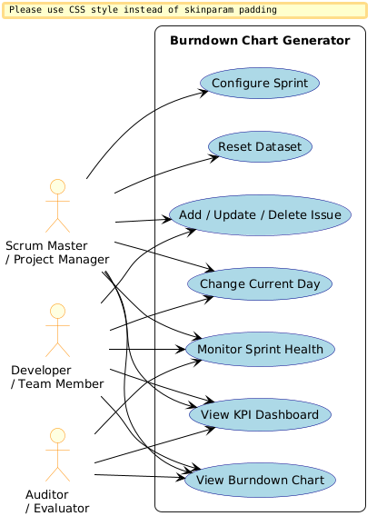
Figure 1: UML Use-Case Diagram - Burndown Chart Generator
7.2 Use case descriptions
UC-01 Add Issue -- Actor: Scrum Master / Developer. Preconditions: dashboard loaded, sprint configured. Main flow: select Add Issue, enter fields, system validates, issue added and totals recalculated. Alternative flow: invalid input rejected with an error. Postconditions: backlog and dependent values reflect the new issue.
UC-02 Update Issue Status and Completion Day -- Actor: Developer. Preconditions: issue exists. Main flow: select issue, set status, provide completion day if Done, system validates against Current Day/Duration, updates issue and Actual Burndown. Alternative flow: out-of-range completion day rejected. Postconditions: issue and burndown reflect the change.
UC-03 Change Current Day -- Actor: any user class. Preconditions: sprint configured. Main flow: move Current Day control, system validates range, recalculates Actual Burndown and KPIs, repositions marker. Postconditions: dashboard reflects the new Current Day.
UC-04 Reset Dataset -- Actor: Scrum Master / Project Manager. Preconditions: application loaded. Main flow: select Reset Data, system discards current state and reloads defaults. Postconditions: backlog, configuration, chart, and KPIs match the default dataset (Appendix A).
7.3 Activity diagram
Primary workflow: Start -> Configure/Load Sprint -> Load Backlog -> Calculate Story Points -> Calculate Ideal Burndown -> Calculate Actual Burndown -> Display Dashboard -> User Adds/Updates/Deletes Issue or Changes Current Day -> Recalculate -> Update Chart/KPIs -> End (or return to dashboard).
What this diagram shows: the step-by-step flow of events when a user opens and uses the app. It starts when the user opens the app, sets up the sprint, and then loops through updating issues or changing the day until they are done.
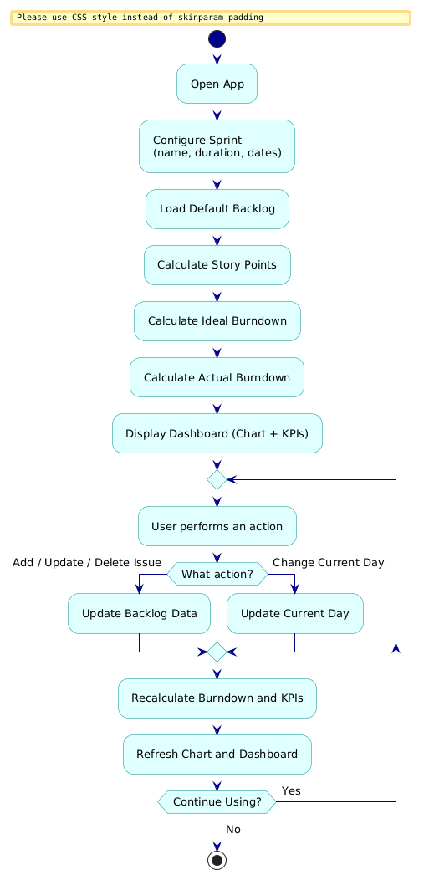
Figure 2: Activity Diagram - Main User Workflow
7.4 Class diagram
Logical components (documented as modules if the implementation uses functions rather than classical OO classes): Sprint, Issue, BurndownEngine, DataManager, ChartManager, UIManager, ValidationManager.
What this diagram shows: the main code modules and how they connect to each other. Each box is a module with its key data and functions. Arrows show which module talks to which. For example, UIManager calls BurndownEngine to get the chart data to display.
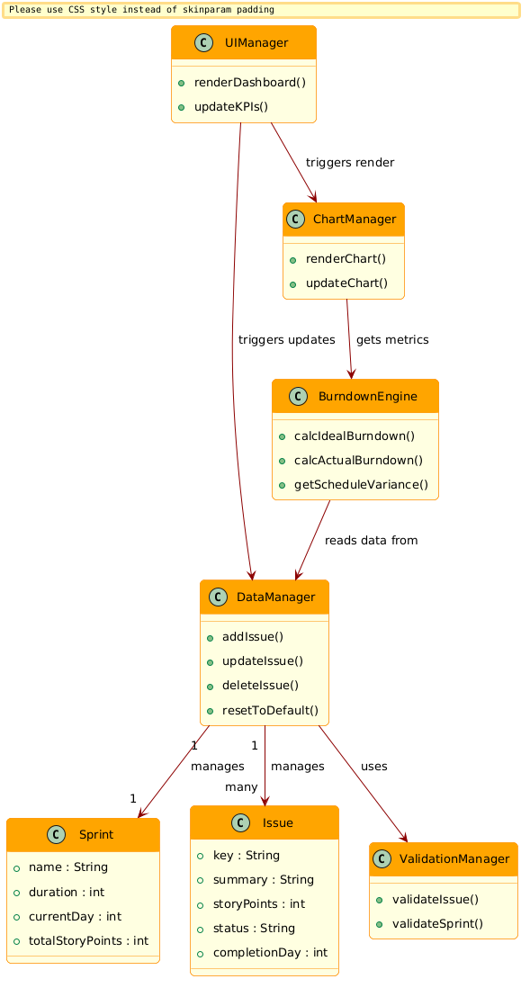
Figure 3: Class Diagram - System Modules and Relationships
7.5 Sequence diagram
Sequence diagrams are to be produced for: loading the dashboard; adding an issue; completing an issue; changing Current Day; and resetting the dataset.
What this diagram shows: the exact order of events when a user adds a new issue. Read it from top to bottom: the user fills the form, the system validates the input, saves it, recalculates the burndown chart, and shows the updated dashboard.
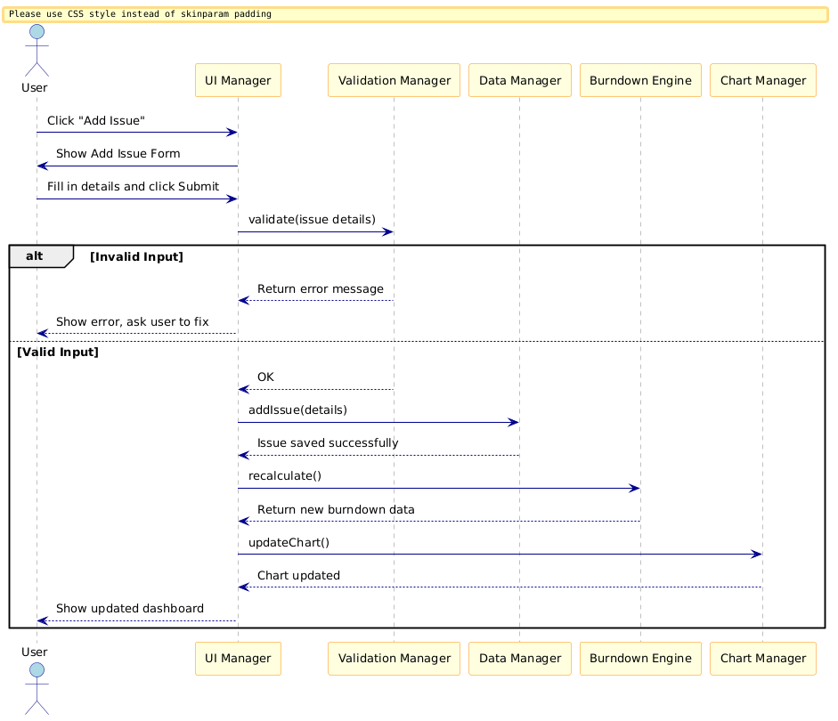
Figure 4: Sequence Diagram - Adding a New Issue
7.6 State diagram
Issue status transitions: To Do -> In Progress -> Done, and To Do -> Done directly. A transition into Done requires a valid completion day (BDC-F-007); moving out of Done clears the previously recorded completion day.
What this diagram shows: the possible statuses an issue (task) can be in and how it moves between them. Every task starts as "To Do", moves to "In Progress" when work begins, and becomes "Done" when completed. A task can also be re-opened or deleted.
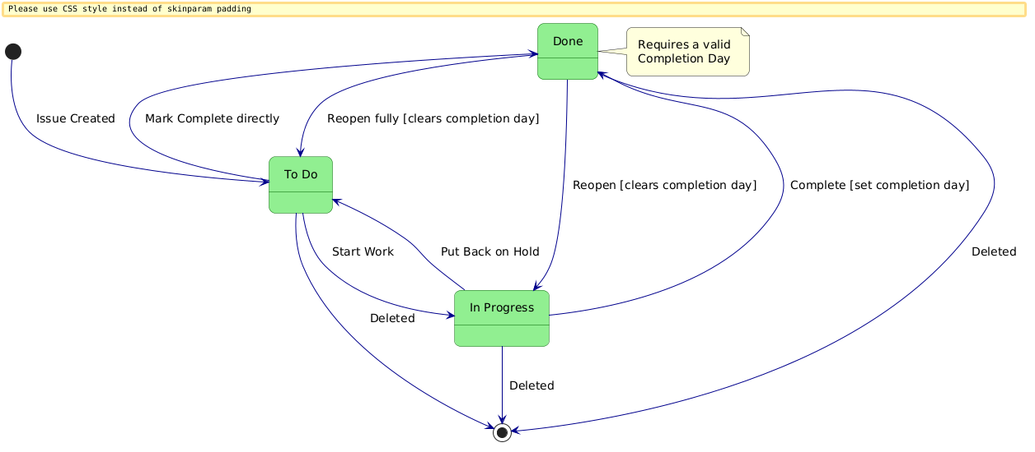
Figure 5: State Diagram - Issue Status Transitions
8. Requirements Traceability Matrix (RTM)
Status uses N (Not run), P (Pass), or A (Failed/Abnormal). No requirement is marked P without actual test evidence.
Req ID | Requirement short | Section ref / Design Spec | Module | Test case(s) | Status (N/P/A) | Comments
BDC-F-001 | Configure sprint | 4.1 / DS-Sprint-01 | UIManager, ValidationManager | TC-F-01 | N | Pending Implementation
BDC-F-002 | Initial commitment | 4.1 / DS-Burndown-01 | BurndownEngine, DataManager | TC-F-02 | N | Pending Implementation
BDC-F-004 | Load default dataset | 4.1 / DS-Data-01 | DataManager | TC-F-04 | N | Pending Implementation
BDC-F-009 | Reset dataset | 4.1 / DS-Data-02 | DataManager | TC-F-09 | N | Pending Implementation
BDC-F-005 | Display backlog | 4.2 / DS-UI-01 | UIManager | TC-F-05 | N | Pending Implementation
BDC-F-006 | Add issue | 4.2 / DS-UI-02 | UIManager, ValidationManager, DataManager | TC-F-06 | N | Pending Implementation
BDC-F-007 | Update status/completion | 4.2 / DS-UI-03 | UIManager, ValidationManager, BurndownEngine | TC-F-07 | N | Pending Implementation
BDC-F-008 | Delete issue | 4.2 / DS-UI-04 | UIManager, DataManager, BurndownEngine | TC-F-08 | N | Pending Implementation
BDC-F-010 | Ideal burndown | 4.3 / DS-Burndown-02 | BurndownEngine | TC-F-10 | N | Pending Implementation
BDC-F-011 | Actual burndown | 4.3 / DS-Burndown-03 | BurndownEngine | TC-F-11 | N | Pending Implementation
BDC-F-012 | Schedule variance | 4.3 / DS-Burndown-04 | BurndownEngine | TC-F-12 | N | Pending Implementation
BDC-F-003 | Current Day control | 4.4 / DS-UI-05 | UIManager, BurndownEngine | TC-F-03 | N | Pending Implementation
BDC-F-013 | Display chart | 4.4 / DS-Chart-01 | ChartManager | TC-F-13 | N | Pending Implementation
BDC-F-014 | Current-day marker | 4.4 / DS-Chart-02 | ChartManager | TC-F-14 | N | Pending Implementation
BDC-F-015 | KPI dashboard | 4.5 / DS-UI-06 | UIManager, BurndownEngine | TC-F-15 | N | Pending Implementation
BDC-NF-001 | Performance | 5 / DS-Perf-01 | BurndownEngine, ChartManager | TC-NF-01 | N | Pending Implementation
BDC-NF-002 | Usability | 5 / DS-UX-01 | UIManager | TC-NF-02 | N | Pending Implementation
BDC-NF-003 | Data integrity/validation | 5 / DS-Val-01 | ValidationManager | TC-NF-03 | N | Pending Implementation
BDC-NF-004 | Compatibility | 5 / DS-UX-02 | UIManager | TC-NF-04 | N | Pending Implementation
BDC-NF-005 | Maintainability | 5 / DS-Arch-01 | All modules | TC-NF-05 | N | Pending Implementation
BDC-SR-001 | XSS prevention | 5.1.2 / DS-Sec-01 | UIManager, ValidationManager | TC-SR-01 | N | Pending Implementation
BDC-SR-002 | Numeric validation | 5.1.2 / DS-Val-02 | ValidationManager | TC-SR-02 | N | Pending Implementation
BDC-SR-003 | Safe localStorage handling | 5.1.2 / DS-Data-03 | DataManager | TC-SR-03 | N | Pending Implementation
BDC-SR-004 | Safe edge-case handling | 5.1.2 / DS-Burndown-05 | BurndownEngine, ValidationManager | TC-SR-04 | N | Pending Implementation
BDC-SR-005 | CSP / dependency safety | 5.1.2 / DS-Deploy-01 | DataManager, deployment config | TC-SR-05 | N | Pending Implementation
Appendix A: Default Simulated Dataset
Sprint Configuration -- Sprint Name: Sprint 1 - Core Features; Duration: 10 days; Current Day: 4; Total Story Points: 50.
Issue Key | Summary | Type | Story Points | Status | Completed Day
PROJ-101 | User Authentication & Session Token Service | Story | 5 | Done | 1
PROJ-102 | Database Schema Migration for User Profiles | Task | 3 | Done | 2
PROJ-103 | REST API Endpoint for Sprint Backlog Query | Story | 8 | Done | 3
PROJ-104 | Implement JWT Refresh Token Expiry Logic | Task | 5 | Done | 4
PROJ-105 | Build Burndown Chart Rendering Canvas UI | Story | 8 | Done | 4
PROJ-106 | UI Form Validation for Task Addition | Bug | 3 | In Progress | --
PROJ-107 | Automated Unit Tests for Calculation Engine | Task | 5 | In Progress | --
PROJ-108 | CSV/JSON Data Export Module | Story | 5 | To Do | --
PROJ-109 | Error Boundary & Toast Notification Component | Task | 3 | To Do | --
PROJ-110 | Sprint Health Summary & KPI Calculation | Story | 5 | To Do | --
Appendix B: Sample Burndown Calculation
Using the default dataset at Current Day 4:
Quantity | Calculation | Result
Total Story Points | 5+3+8+5+8+3+5+5+3+5 | 50
Completed by Day 4 | 5+3+8+5+8 (PROJ-101..105) | 29
Actual Remaining (Day 4) | 50 - 29 | 21
Ideal Remaining (Day 4) | 50 x (1 - 4/10) | 30
Variance | 30 - 21 | +9
Schedule Status | Variance > 1 | Ahead of Schedule
Appendix C: Data Model
Sprint
Field | Type | Description
sprintName | String | Human-readable sprint name.
durationDays | Integer (> 0) | Total sprint length in days.
startDate / endDate | Date | Sprint start and end dates; end must follow start.
currentDay | Integer (0 to durationDays) | Day currently selected via the Current Day control.
Issue
Field | Type | Description
issueKey | String (unique) | Jira-style identifier, e.g., PROJ-101.
summary | String | Short description of the issue.
issueType | Enum: Story | Task | Bug | Category of the issue.
storyPoints | Number (>= 0) | Relative effort estimate.
status | Enum: To Do | In Progress | Done | Current workflow state.
completedDay | Integer or null | Day marked Done; required when status = Done.
Appendix D: Requirement ID Reference
- Functional Requirements: BDC-F-001 through BDC-F-015 (Section 4).
- Non-Functional Requirements: BDC-NF-001 through BDC-NF-005 (Section 5).
- Security Objectives: SO-01, SO-02 (Section 5.1.1).
- Security Requirements: BDC-SR-001 through BDC-SR-005 (Section 5.1.2).

